D7 Expert Review Report
Topological Role Consistency and Structural Representativeness | v2.1
Status: Research package complete; production DQR release blocked
Run: D7-LOCAL-20260726T032027Z
Coverage: 2025-08-01 00:00:00 to 2026-04-13 23:00:00

1. Executive verdict
D7 v2.1 is complete as a research and review package. The Local, Sensitivity and Shadow V2 tracks, frozen method assets, validation, plotting data, figures, reports and audit records are present and reproducible.
Research topology is author-confirmed and reconciled to an installation register. Production release remains blocked by documentary approval, maintenance provenance and support/localization gates: L1=48, L2=8, L3=0; swap Top-1 is 0.70 (95% CI 0.57-0.80, n=60). D7_total, D7_forDQR and D6 final arbitration therefore remain empty.

2. Scope and dimensional independence
- D7 evaluates spatial role identity and structural representativeness, not hardware fault type.
- D1 covers sensor-intrinsic health; D2 covers continuity/availability; D4 covers physical value/rate constraints; D6 covers temporal synchronization between parallel counterparts.
- Local D7 consumes no D1-D6 score, state or event. D1/D2/D4 appear only in the isolated Sensitivity Track.
- QR/QIR provide exogenous context only. Low D7_raw is unlabeled structural evidence, not a confirmed fault.

3. Current data and outputs
Sensitivity provenance is bound to frozen D1 release D1REL-1.3.0-f6074be3751f and exact D2/D4/Local artifact hashes. Production arbitration remains pending_not_produced; no D7_forDQR output was generated.
Measure | Current result | Interpretation
Hourly windows | 86,016 | 2025-08-01 00:00:00 to 2026-04-13 23:00:00
D7 raw | mean 3.097; median 3.114 | Comparative research evidence
Low-score fraction | 46.0% | Not a fault prevalence estimate
Candidate events | 529 | Unreviewed and unlabeled
OOD hold | 15.5% | Explicit posterior rejection
D7 total / D6 evaluable | 0 / 0 | Correctly blocked

4. Support and applicability
Tier | Templates | Policy
L1 | 48 | Gating eligible only after all contracts pass
L2 | 8 | Gating eligible only after all contracts pass

ORP is forced to L1 diagonal robust Z with alpha=1.00 and cannot auto-promote. Missing, OOD and limited evidence is represented by status and NaN, never by a fabricated low production score.

5. Validation and sensitivity
Criterion | Estimate | Target | Result
swap_AUROC | 0.912 | >= 0.90 | PASS
swap_AUPRC | 0.870 | >= 0.80 | PASS
swap_Top1 | 0.700 | >= 0.80 | FAIL
common_mode_FAR | 0.046 | <= 0.10 | PASS
zone_coherent_FAR | 0.057 | <= 0.10 | PASS
switch_chatter_rate | 0.000 | <= 0.05 | PASS

Same-line position swaps are scored with frozen templates. Freeze, temporal ramps, common/zone-coherent changes, DO4 floor behavior and dropout are orthogonality controls. Detection and FAR pass, but node localization remains below release quality.
Track metric | Estimate | Target | Result
IE_track | 0.048 | <=0.20 | PASS
event_jaccard | 0.825 | >=0.80 | PASS
culprit_spearman | 0.962 | >=0.80 | PASS

6. Topology and D6 interface
The declared registry contains 14 nodes, 10 longitudinal edges and seven peer pairs. 5 finite candidate mappings exceed the report-only review threshold. They cannot mutate production topology or activate Veto.
- Ordinal research topology is confirmed; maintenance provenance, production documentary audit and two-person approval remain pending.
- D7-to-D6 zone consensus is present but every row is non-evaluable for final arbitration.
- D6 protected columns remain unchanged because no D6 write path exists.

7. SCI figure review
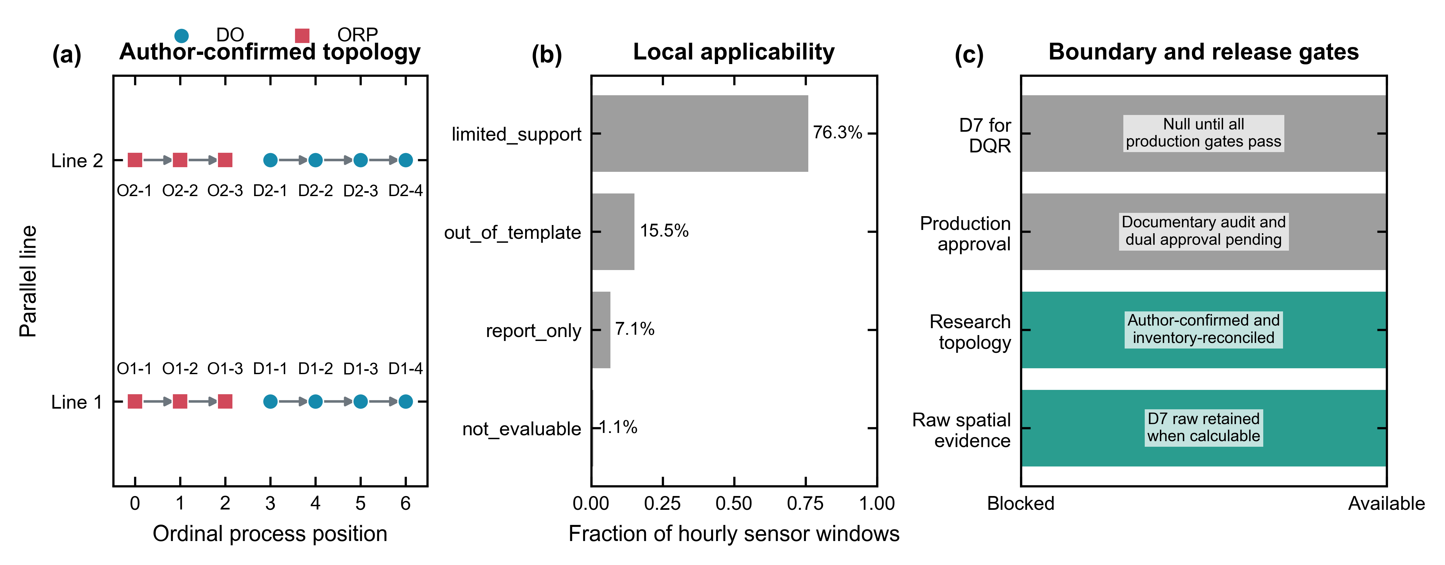
Figure D7-1 | Author-confirmed topology, applicability and release boundary.
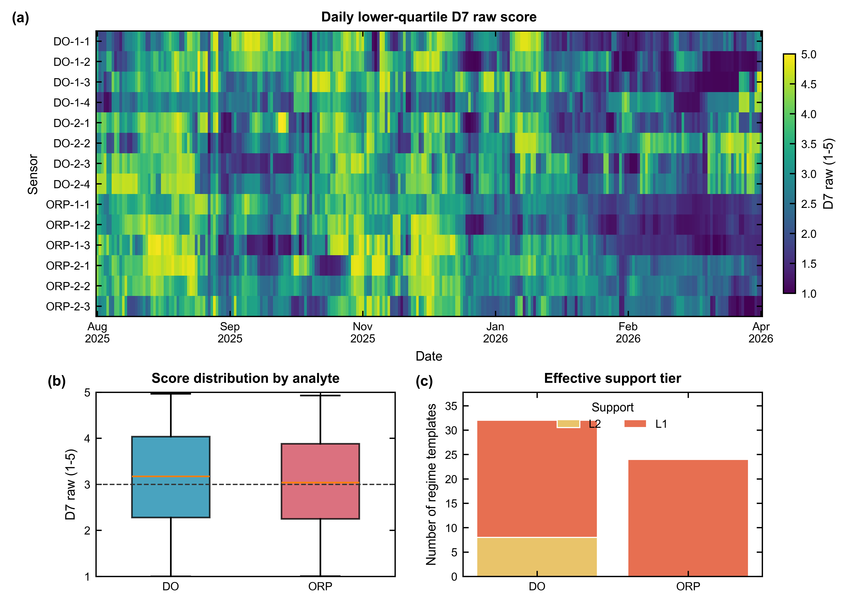
Figure D7-2 | Spatiotemporal D7 structure and effective support.
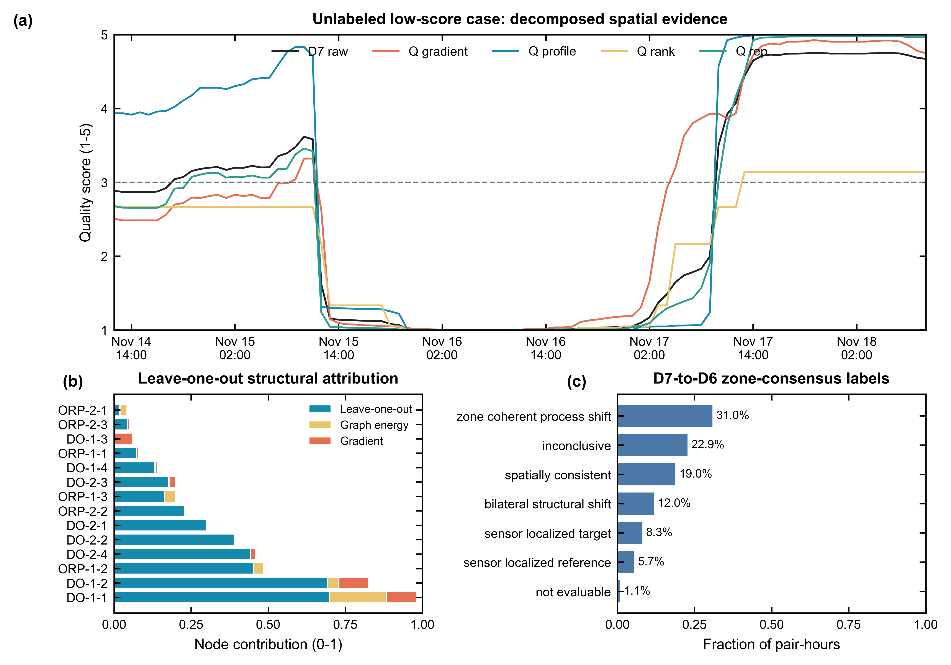
Figure D7-3 | Evidence decomposition, node influence and zone consensus.
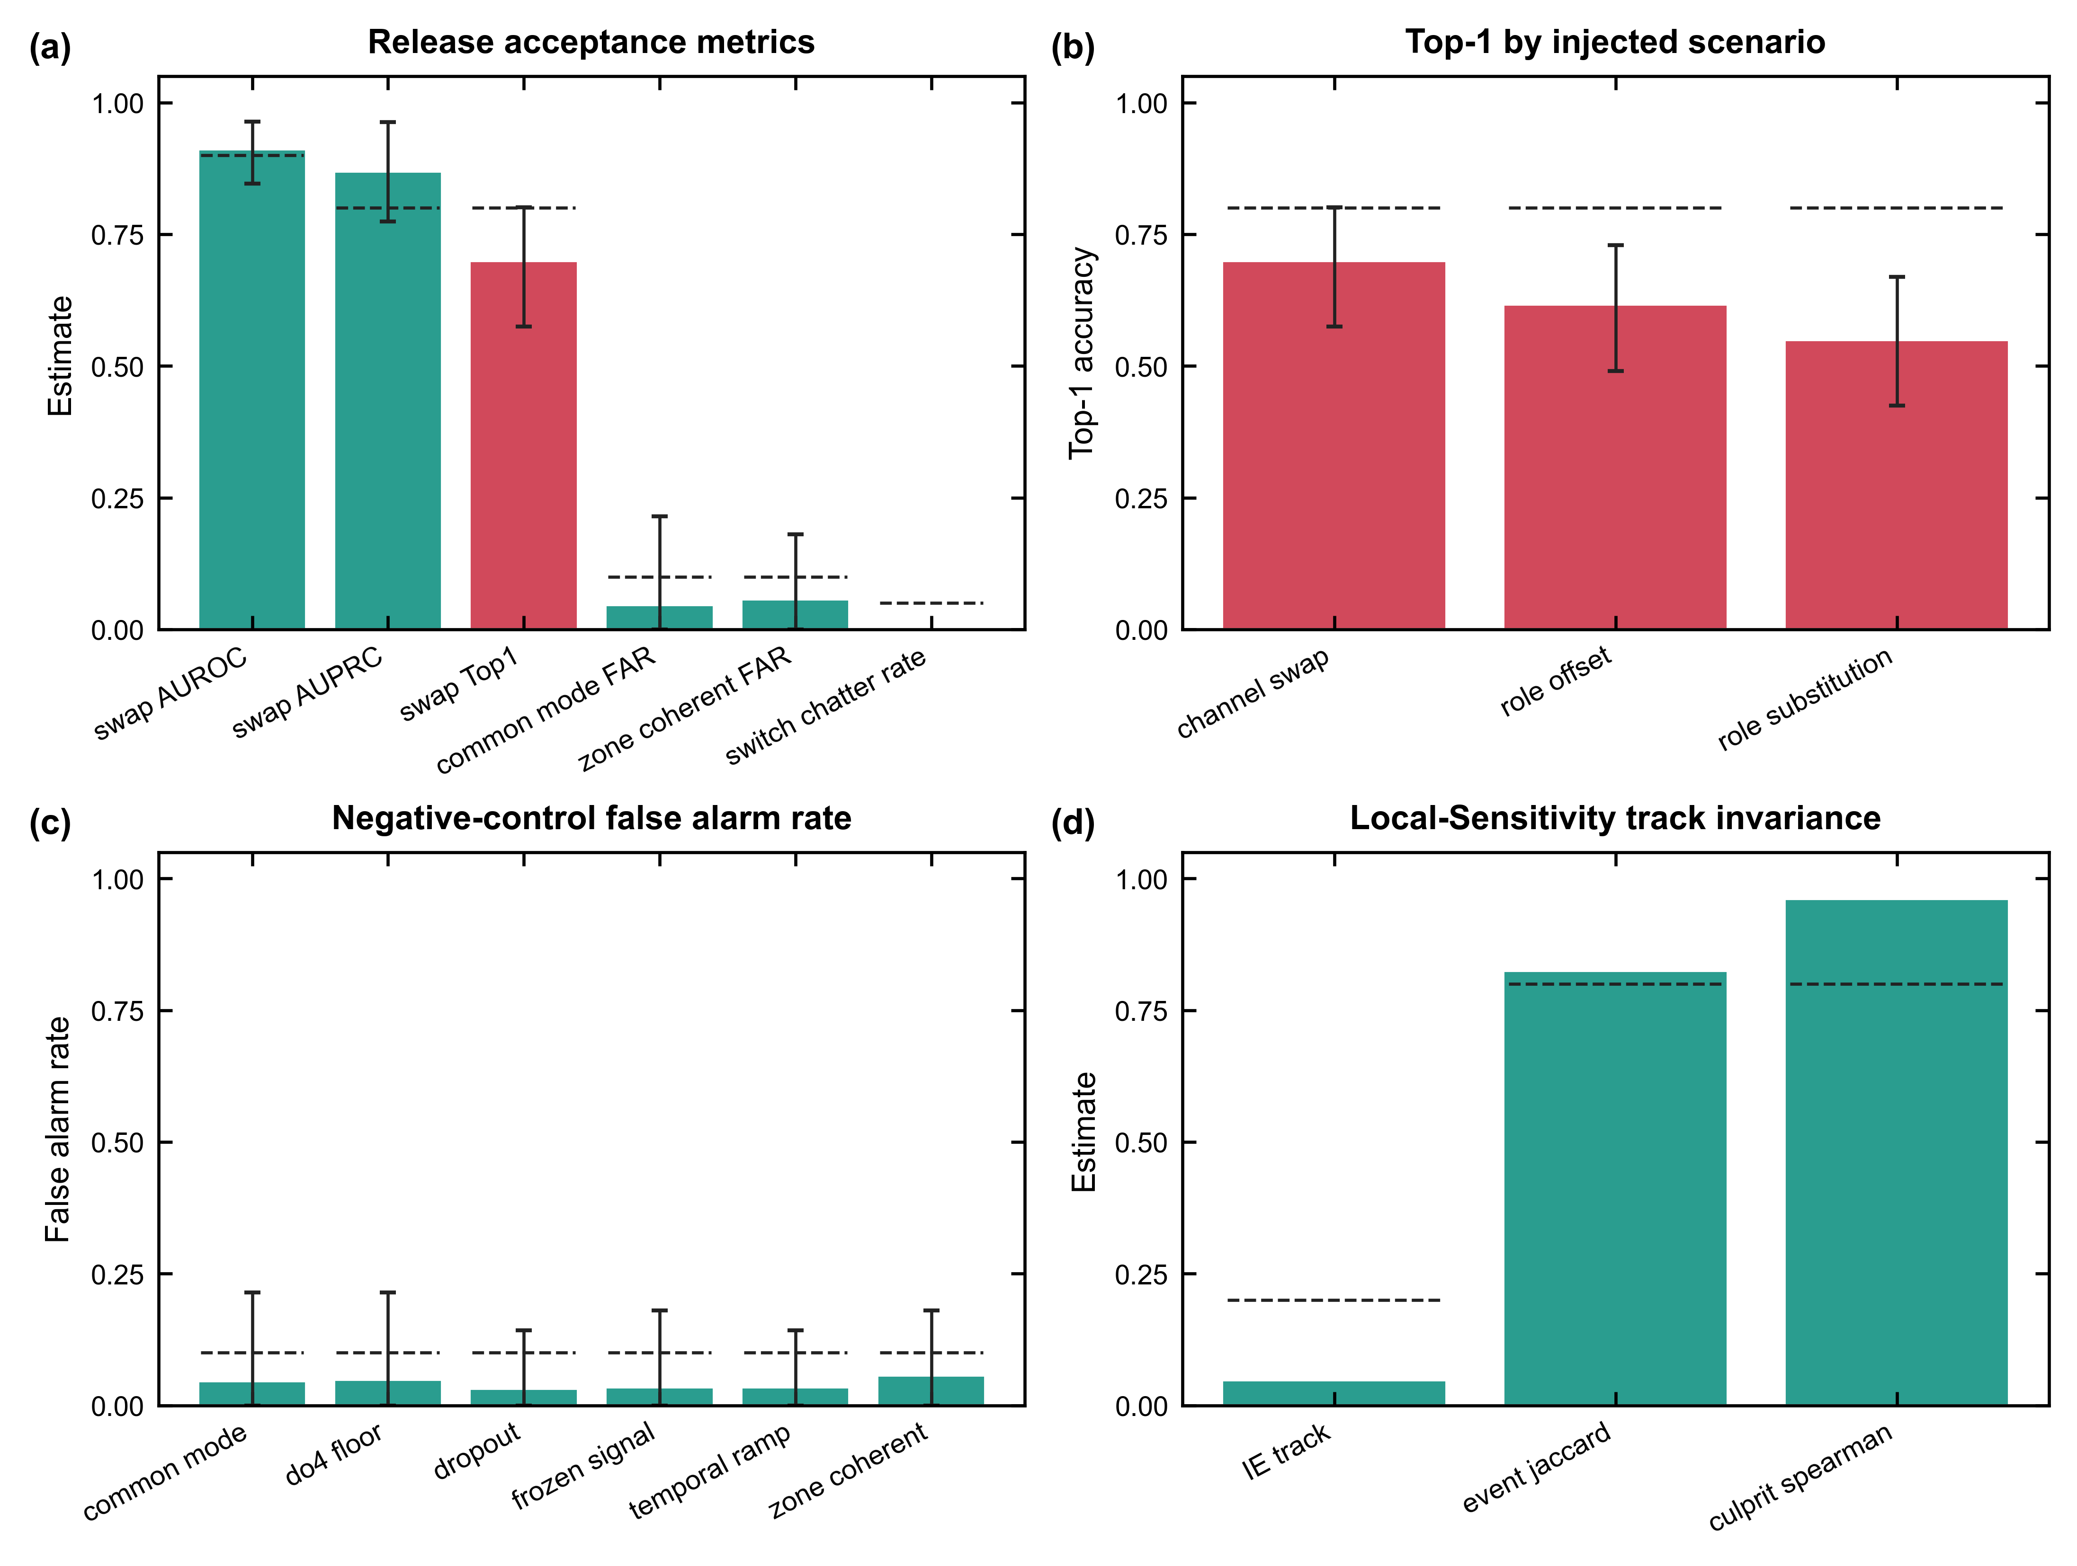
Figure D7-4 | Validation and Local-Sensitivity invariance.
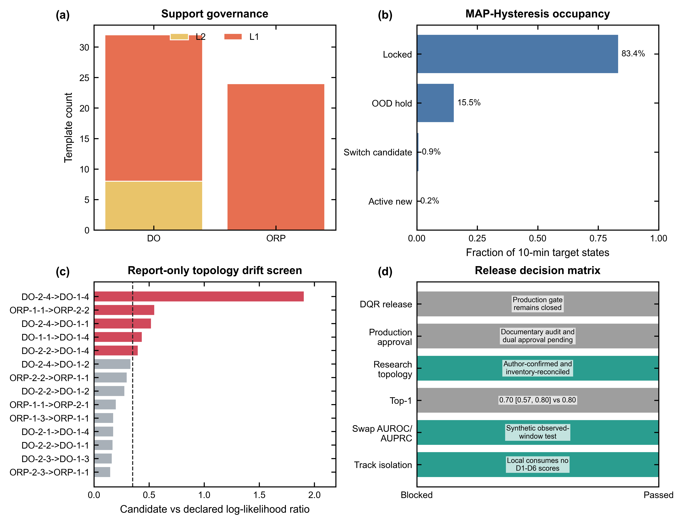
Figure D7-5 | Support, regime, topology and release governance.

8. Critical limitations
- Research topology is confirmed, but production documentary evidence and maintenance provenance are not dual-approved.
- Effective support is L1=48, L2=8, L3=0; only production-approved L3 may gate.
- Swap Top-1 is 0.70 (95% CI 0.57-0.80) versus the 0.80 target.
- The 529 candidate events lack external truth and cannot be called confirmed faults.
- Regime transition FAR and topology candidate recall require external truth.

9. Release decision
The branch is suitable for expert review and merge as a research implementation with explicit production gates. It is not suitable for activation in WW-DQS/DQR arbitration.
- Complete the maintenance/documentary audit and obtain two independent approvals.
- Regenerate all topology-bound templates and hashes.
- Accumulate qualified multi-season effective blocks and pass support exit criteria.
- Raise blocked-holdout Top-1 to at least 0.80 without weakening negative-control FAR.
- Add prospective field-confirmed cases before activating D7_total or D6 final arbitration.

